MEDICARE

Project Based Learning - V (22AI014)

Submitted by

BHUVAN GOYAL (2310993804)
DAKSH NAGPAL (2310993806)
DASHIV SHARMA (2310993807)

Semester: 5


BE-CSE (Artificial Intelligence)

Guided by
Dr. Harshvardhan

CHITKARA UNIVERSITY INSITUTE OF ENGINEERING & TECHNOLOGY
CHITKARA UNIVERSITY, RAJPURA
NOVEMBER 2025

ACKNOWLEDGEMENTS

With immense pleasure, we Mr. Bhuvan Goyal, Mr. Daksh Nagpal, Mr. Dashiv Sharma present the project report titled “MEDICARE” as part of the curriculum of B.E. CSE (AI).
I would like to express our sincere thanks to Dr. Harshvardhan for his valuable guidance and support throughout the completion of this project.
We also extend our heartfelt gratitude to our Dean, Dr. Sushil Kumar Narang, for giving us the opportunity to work on this project titled “MEDICARE.” Without their constant support and suggestions, this project would not have been possible.

Name: Bhuvan Goyal
Roll No: 2310993804
Signature:

Name: Daksh Nagpal
Roll No: 2310993806
Signature:

Name: Dashiv Sharma
Roll No: 2310993807
Signature:

Table of Contents
Serial No. | Title | Page No
 | Introduction | 4
 | Problem Formulation | 5-6
 | Methodology | 7-8
 | Key Features | 9-10
 | Hardware and Software Requirements | 11-12
 | Results (Screenshots) | 13-15
 | Code | 16-21
 | Conclusion and Future Scope | 22
 | References | 23

Introduction

Primary healthcare settings are increasingly under pressure, facing significant challenges in managing patient intake efficiently. Patients often endure long wait times, which can lead to delayed diagnoses. A major bottleneck in this process is the initial triage, which is frequently inefficient due to incomplete symptom reporting by patients. This inefficiency places a heavy burden on clinicians, who must dedicate valuable time to repetitive administrative tasks like collecting basic patient information, diverting their focus from critical analysis and decision-making.
The problem is compounded by the inherent difficulty many patients face in accurately articulating their symptoms. Vague or incomplete descriptions can lead to misinterpretation, potentially resulting in misdiagnosis or a critical delay in necessary care. This communication gap highlights a clear and pressing need for an intelligent system. Such a system must be autonomous, capable of interacting with patients effectively, understanding their symptoms, and structuring the collected data into coherent, actionable reports to streamline clinical workflows.
To address these challenges, this project introduces "MediCare," an agentic AI-powered clinical triage assistant. MediCare is specifically designed to optimize and streamline the initial stages of patient interaction in primary care environments. The system integrates a powerful combination of agentic AI, advanced natural language processing (NLP), and medical knowledge graphs. This technological fusion allows MediCare to move beyond simple data collection and perform intelligent, context-aware analysis of a patient's condition.
The core function of MediCare is to autonomously engage patients through a conversational interface, gathering and interpreting their symptom descriptions in real-time. The system intelligently extracts key medical entities, dynamically asks relevant follow-up questions to clarify information, and maps the patient's inputs against a structured knowledge base to identify possible conditions. The final output is a comprehensive triage report, complete with a recommended urgency level and a suggested medical specialty. By automating this front-line decision support, MediCare aims to significantly reduce clinician workload, enhance early detection of serious conditions, and ultimately improve the overall patient experience.

Problem Formulation

In primary healthcare settings, patients often experience long wait times and delayed diagnoses due to inefficient initial triage and incomplete symptom reporting. Clinicians are burdened with repetitive tasks like collecting basic patient information, which reduces their time for critical analysis. Additionally, many patients struggle to accurately describe their symptoms, leading to misdiagnosis or delayed care. There is a need for an intelligent, autonomous system that can interact with patients, understand their symptoms, and generate structured pre-diagnosis reports to streamline clinical workflows and improve early detection.

Components:

User Interface:

A chatbot interface is created using StreamLit to capture patient inputs through text or voice. Basic validations ensure clarity and completeness of the provided symptom descriptions.
- Input Validation
Basic frontend and backend validations are implemented to ensure clarity and completeness of the provided symptom descriptions before processing.

Natural Language Processing:
Input is cleaned (lowercasing, punctuation removal). Pre-trained models like BioClinicalBERT extract medical entities such as symptoms, duration, and severity using NER techniques.
- Agentic AI Workflow:
A LangChain agent orchestrates the triage process by Asking relevant follow-up questions. Managing logical flow between components.

- Dynamic Follow-up Questioning:
The agent intelligently asks relevant follow-up questions based on initial inputs to clarify ambiguity and gather more specific details from the patient.
- Knowledge Graph Integration:
A Neo4j-based medical knowledge graph maps symptoms to diseases and related specialties. The agent queries this graph to infer possible conditions and recommend departments.
- Condition and Specialty Inference:
The agent actively queries the knowledge graph, using the extracted symptoms to infer possible conditions and recommend the appropriate medical department.
- Triage Report Generation
A structured report is generated summarizing extracted symptoms, urgency level, and suggested specialist. This report can be formatted using simple templating or summarization models.
- Testing and Deployment
The system is tested using sample inputs and real symptom cases. Final deployment is done on Streamlit Cloud for easy access and demonstration.

Methodology

The methodology adopted for developing MediCare, an AI-powered clinical triage assistant, involves a comprehensive and structured AI workflow integrating natural language processing, agentic reasoning, and medical knowledge graph inference. The process follows a sequence of systematic stages from user interaction to intelligent report generation and deployment, as detailed below:

1. User Interface Development
A user-friendly and interactive chatbot interface is designed using Streamlit, providing text based communication channels for patients.
- The interface serves as the entry point of the system, enabling patients to describe their symptoms in natural language.
- Basic input validation and user guidance are incorporated to ensure clarity, coherence, and completeness of the symptom descriptions.
- Error-handling and prompt suggestions assist users who provide incomplete or vague symptom data.
- The interface ensures accessibility, a smooth conversation flow, and an intuitive experience even for non-technical users, thereby enhancing user engagement and data accuracy.
2. Input Validation & Preprocessing
- Text data is standardized through lowercasing, tokenization, punctuation removal, and stop-word elimination to maintain consistency.
- Ambiguous or irrelevant information is filtered out, while domain-specific terms such as “pain,” “fever,” or “swelling” are retained and prioritized.
- Basic backend validation checks are applied to handle missing or inconsistent entries, ensuring every record passes predefined quality thresholds.

3. Natural Language Processing(NLP)
- Pre-trained biomedical transformer models like BioClinicalBERT are fine-tuned for Named Entity Recognition (NER) to identify entities such as symptoms, duration, severity, affected body part, and related context.

- Extracted entities are normalized using standard medical terminologies, ensuring compatibility with the downstream knowledge graph.

- The NLP layer also performs intent recognition, identifying whether the patient query is diagnostic, informative, or symptom-based.

4. Agentic AI Workflow
- The LangChain agent acts as the intelligent controller that connects the NLP layer, knowledge graph, and inference modules.
- It dynamically determines the next action — whether to ask a follow-up question, fetch related conditions, or generate a report.
- The agent ensures smooth communication between components, managing task dependencies, tool invocation, and logical branching during triage.

5. Dynamic Follow-up Questioning
- Based on the extracted entities and confidence scores, the AI agent intelligently asks relevant questions such as “How long have you been experiencing this?” or “Is the pain continuous or occasional?”
- Each new response is integrated into the knowledge base in real time, refining the system’s understanding of the patient’s condition.
- This interactive feedback loop mimics real doctor–patient communication and helps capture details that static forms often miss.

6. Knowledge Graph Integration
- The knowledge graph stores relationships such as Symptom → Condition → Specialist → Treatment Category, providing a structured representation of medical knowledge.
- When the AI agent receives extracted symptoms, it queries this graph to identify possible conditions, their likelihood, and the appropriate department for consultation.
- This approach combines data-driven AI predictions with rule-based reasoning, ensuring the system remains explainable, interpretable, and medically grounded.
7. Condition and Specialty Inference
- Using confidence-weighted reasoning, the system identifies and ranks possible health conditions corresponding to the extracted symptoms.
- Each condition is associated with a severity score, indicating whether the case is mild, moderate, or urgent.
- The AI then recommends the most suitable medical specialty, such as cardiology, neurology, or dermatology, based on the inferred results.

8. Testing and Deployment
- Unit and integration tests are performed to validate accuracy across all modules—NLP, agentic workflow, and knowledge graph queries.
- Multiple real-life symptom scenarios are simulated to assess the correctness of recommendations and the robustness of follow-up questioning.
- Deployment is done on Streamlit Cloud, offering easy accessibility and a seamless user interface for both patients and clinicians.

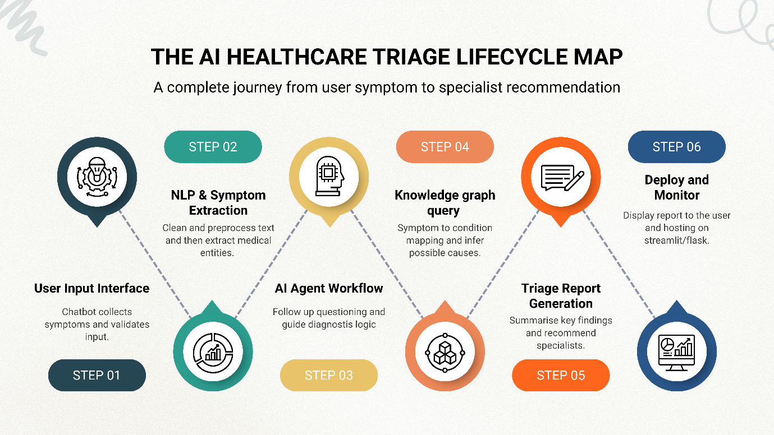

Key Features

Conversational Clinical Chatbot:

An interactive chatbot built using Streamlit allows patients to describe symptoms through text. It mimics doctor–patient conversation and guides users with prompts to ensure accurate and complete symptom descriptions.

2. Automated Symptom Extraction:

The system uses BioClinicalBERT to extract key medical entities such as symptoms, duration, severity, and body parts via NER.
This ensures structured, precise, and clinically relevant data for triage analysis.

3. Agentic AI Workflow Management:

A LangChain agent orchestrates all modules, managing logic, flow, and tool invocation. It autonomously decides when to ask questions, run inference, or generate reports, ensuring smooth triage operation.

4. Dynamic Follow-up Questioning:

The AI agent intelligently asks relevant follow-up questions based on user input and model confidence. This reduces ambiguity and helps capture more accurate health details from patients.

5. Medical Knowledge Graph Integration:

A Neo4j-based medical knowledge graph connects symptoms to diseases and related specialists. It enables structured reasoning, explainable AI decisions, and data-driven condition mapping.

6. Condition & Specialty Recommendation:

By combining NLP and knowledge graph insights, the system infers possible conditions and their severity. It recommends the most suitable medical specialty or department for the patient’s case.

7. Explainable and Transparent Reasoning

Every AI-generated recommendation is backed by a clear reasoning path from the knowledge graph. This ensures interpretability, transparency, and trust in clinical decisions.

8. Testing and Evaluation Framework:

The system is tested on real and sample patient data to assess accuracy and stability.
Each module - NLP, agent, and graph reasoning - is validated independently for reliability.

9. Cloud Deployment and Accessibility:
Deployed on Streamlit Cloud, the system offers secure, real-time web access across devices. Its lightweight design ensures fast, scalable, and user-friendly healthcare triage.

Software and Hardware Requirements

Software:

Programming Languages:
- Python: For backend logic, NLP pipelines, and AI workflow integration.
- JavaScript: For enhancing interactivity within the Streamlit - based user interface.

Artificial Intelligence & NLP:
- BioClinicalBERT (Hugging Face): Pre-trained model for medical entity extraction and symptom understanding.
- T5 / BART (Hugging Face): For summarizing triage reports and generating readable medical summaries.
- LangChain: To manage agentic AI workflows, prompt execution, and logical flow control.
- SpaCy / NLTK: For text preprocessing, tokenization, and language cleaning.
- Transformers Library: For deploying and fine-tuning pre-trained NLP models from Hugging Face Hub.

External APIs & Model Integrations:
- Hugging Face API: For accessing hosted NLP models like BioClinicalBERT and T5 without local heavy computation.
- Medical Knowledge APIs: Optional integration for condition-symptom mapping and enhancing graph accuracy.

Knowledge Representation & Databases:
- Neo4j: Graph database for modeling relationships between symptoms, diseases, and specialists.
- Py2Neo: Python library to interact with the Neo4j database and execute queries programmatically.

Web & Interface Development:
- Streamlit: For building and deploying the chatbot-style triage interface.
- Flask (with Flask-CORS): For lightweight backend API communication between modules.

Development Tools:
- Google Colab: For testing NLP models and API-based workflows using GPU runtime (T4 GPU).
- Visual Studio Code (VS Code): For code editing, version control, and debugging.

Hardware:

- Processor:
A modern processor such as Intel i5 or AMD Ryzen 5 (or higher) to efficiently handle backend scripts, NLP workflows, and database queries.
- Memory (RAM):
Minimum 8GB RAM, recommended 16GB+ for smooth AI inference, model interactions, and API requests.
- Storage:
Minimum 256GB SSD for storing code files, temporary datasets, and output reports.
- GPU:
Model inference and fine-tuning performed on Google Colab (T4 GPU) using Hugging Face models.
- Display:
1920×1080 (Full HD) monitor or laptop screen for clear visualization of chatbot interactions, triage reports, and analytics dashboards.
- Internet Connectivity:
Stable broadband/Wi-Fi connection required for API calls, Hugging Face model access, and Streamlit Cloud deployment.
RESULTS:-

- Home Page

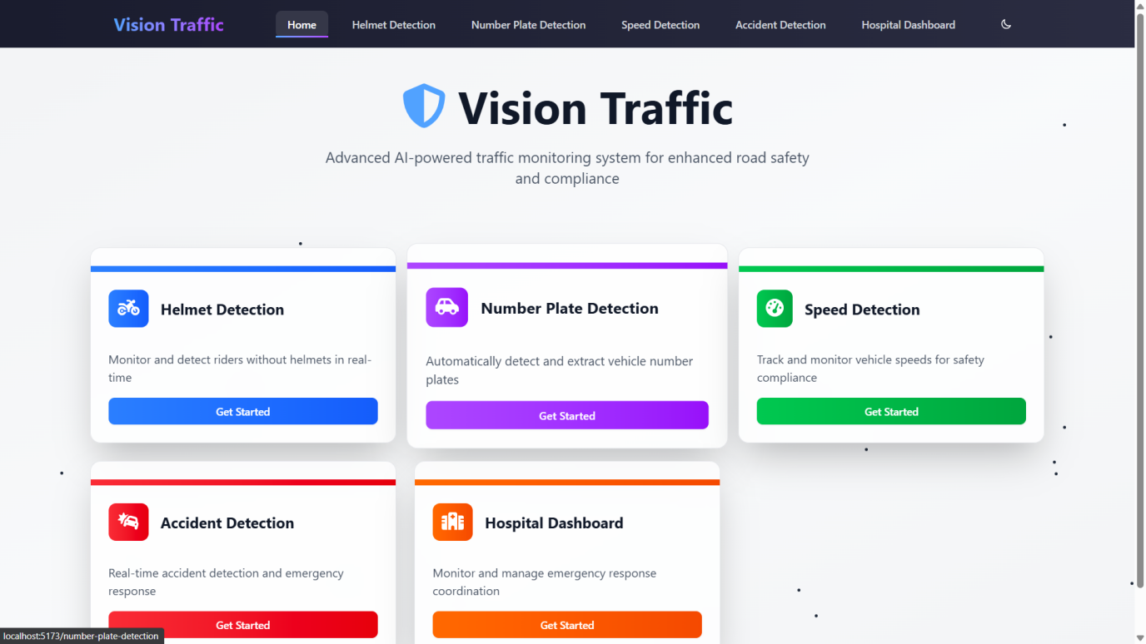

- Helmet Detection

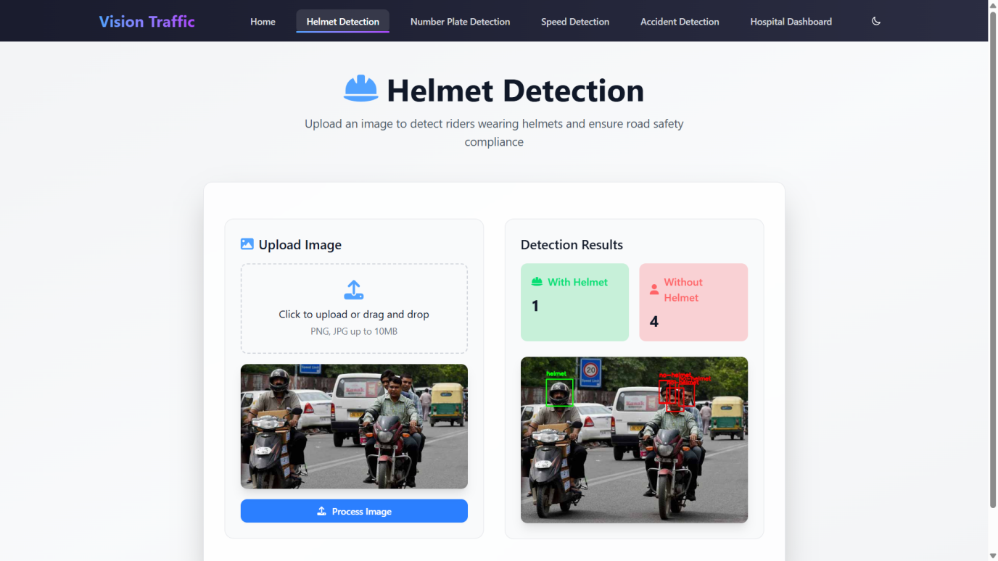

- Number Plate Detection

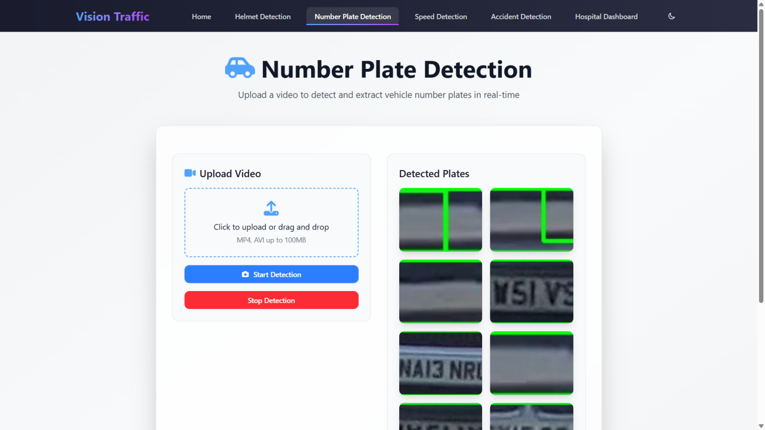

- Accident Detection

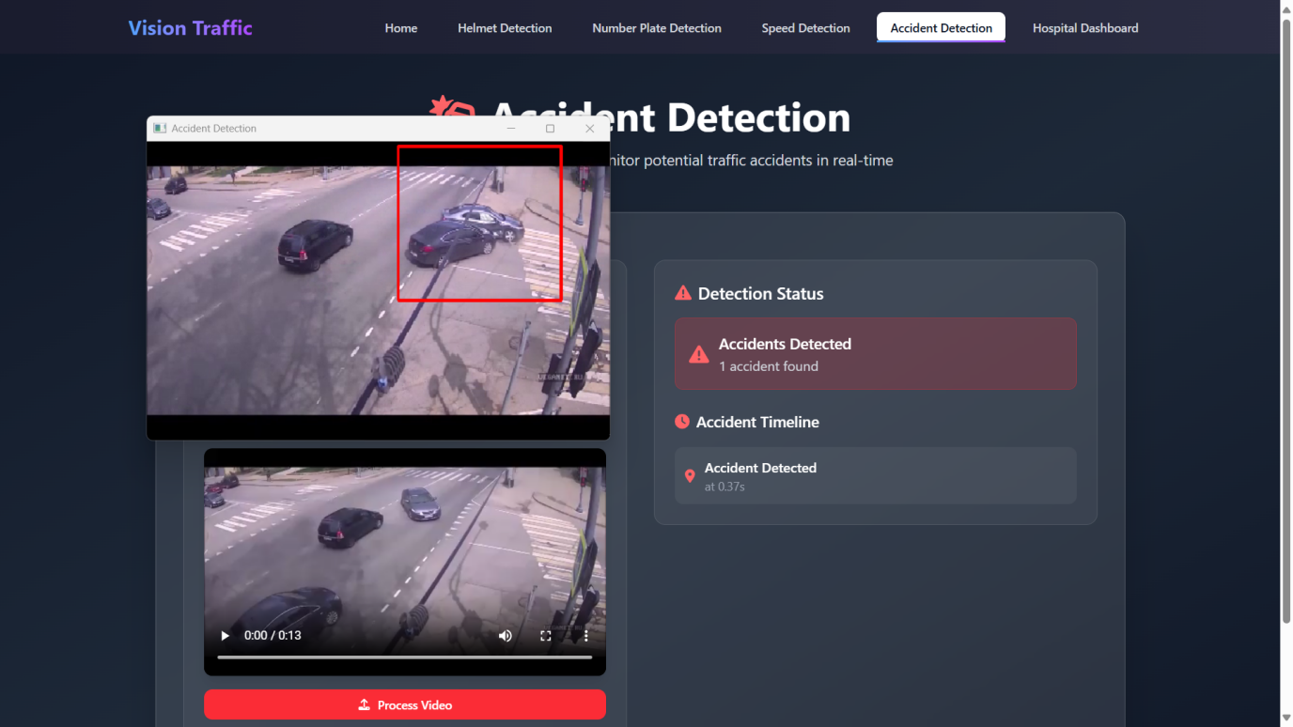

- Hospital Dashboard

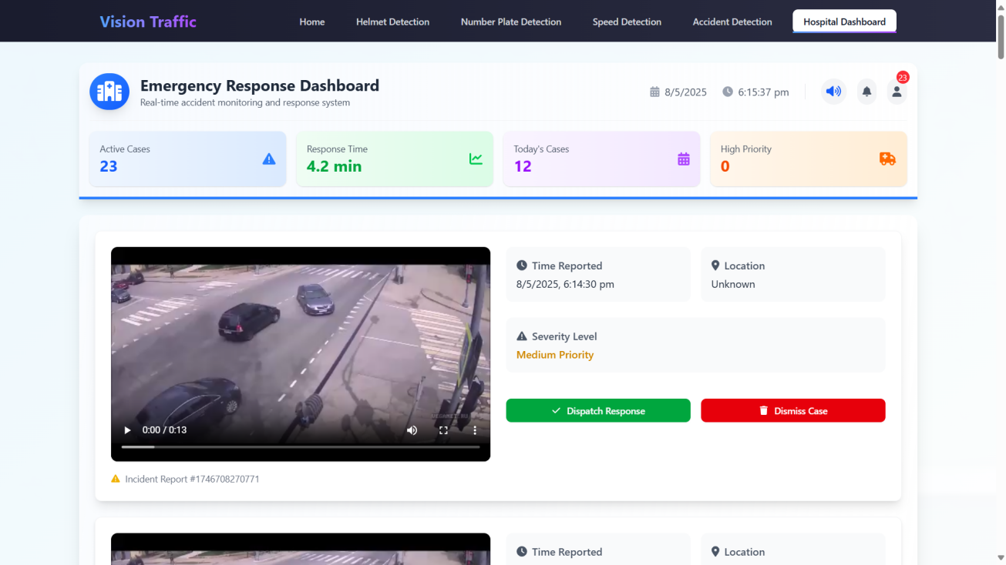

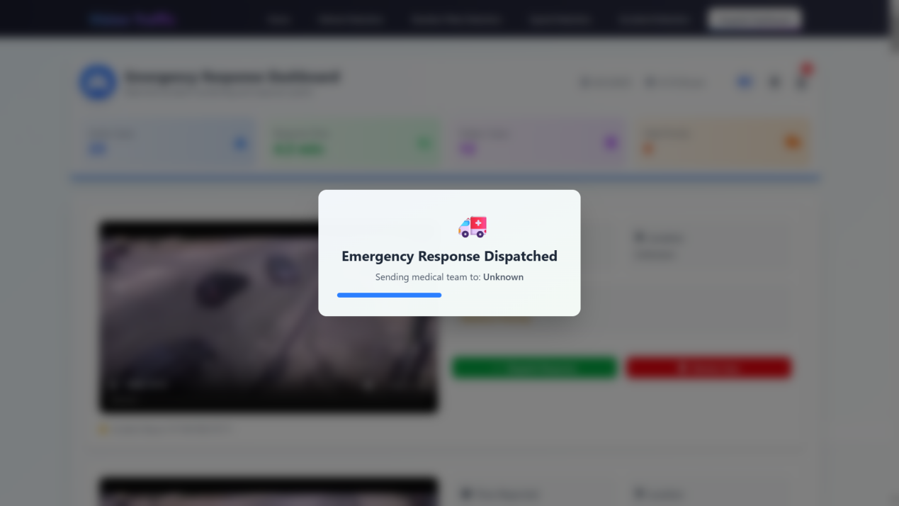

CODE (Model Trainings)

- Accident training

from flask import Flask, request, jsonify, send_from_directory
from flask_cors import CORS
import os

app = Flask(_name_)
CORS(app)

UPLOAD_FOLDER = 'uploads'
RESULT_FOLDER = 'results'
ALLOWED_EXTENSIONS = {'png', 'jpg', 'jpeg', 'mp4'}

app.config['UPLOAD_FOLDER'] = UPLOAD_FOLDER
app.config['RESULT_FOLDER'] = RESULT_FOLDER

os.makedirs(UPLOAD_FOLDER, exist_ok=True)
os.makedirs(RESULT_FOLDER, exist_ok=True)

from ultralytics import YOLO
import cv2
import numpy as np
import uuid
import os

model = YOLO('helmet-detection/best.pt')

def detect_helmets(image):
results = model(image)
detections = results[0].boxes.data

with_helmet = 0
without_helmet = 0

for det in detections:
x1, y1, x2, y2, conf, cls = det.tolist()
class_id = int(cls)
label = "helmet" if class_id == 0 else "no-helmet"

if label == "helmet":
with_helmet += 1
else:
without_helmet += 1

color = (0, 255, 0) if label == "helmet" else (0, 0, 255)
cv2.rectangle(image, (int(x1), int(y1)), (int(x2), int(y2)), color, 2)
cv2.putText(image, label, (int(x1), int(y1) - 10),
cv2.FONT_HERSHEY_SIMPLEX, 0.5, color, 2)

output_filename = f"output_{uuid.uuid4().hex}.jpg"
output_path = os.path.join("uploads", output_filename)
cv2.imwrite(output_path, image)

return with_helmet, without_helmet, output_path, output_filename

plate_cascade = cv2.CascadeClassifier("number-plate-detection/model/haarcascade_russian_plate_number.xml")

def detect_number_plate(image_path):
image = cv2.imread(image_path)
gray = cv2.cvtColor(image, cv2.COLOR_BGR2GRAY)
plates = plate_cascade.detectMultiScale(gray, scaleFactor=1.1, minNeighbors=4)

for (x, y, w, h) in plates:
cv2.rectangle(image, (x, y), (x + w, y + h), (255, 0, 0), 2)
roi = image[y:y+h, x:x+w]
filename = f"plate_{uuid.uuid4().hex}.jpg"
filepath = os.path.join("plates", filename)
cv2.imwrite(filepath, roi)

return plates
@app.route("/detect/helmet", methods=["POST"])
def detect_helmet_api():
if "image" not in request.files:
return jsonify({"error": "No image uploaded"}), 400

file = request.files["image"]
image = np.frombuffer(file.read(), np.uint8)
image = cv2.imdecode(image, cv2.IMREAD_COLOR)

with_helmet, without_helmet, output_path, output_filename = detect_helmets(image)

return jsonify({
"with_helmet": with_helmet,
"without_helmet": without_helmet,
"output_image_url": f"http://127.0.0.1:5000/uploads/{output_filename}",
})
from ultralytics import YOLO
import cv2
import os

model_acc = YOLO("accident-detection/best.pt")

accident_list = []
stop_processing = False
accident_detected = False
total_accidents = 0
accident_timestamps = []
last_accident_time = -5

def process_video_acc(video_path):
global stop_processing, accident_detected, total_accidents, accident_timestamps, last_accident_time
stop_processing = False
accident_detected = False
total_accidents = 0
accident_timestamps.clear()
last_accident_time = -5

cap = cv2.VideoCapture(video_path)
fps = cap.get(cv2.CAP_PROP_FPS)
frame_count = 0

while cap.isOpened():
success, frame = cap.read()
if not success or stop_processing:
break
frame_count += 1
time_in_seconds = frame_count / fps

results = model_acc(frame)
for result in results:
for box in result.boxes:
x1, y1, x2, y2 = map(int, box.xyxy[0])
conf = float(box.conf[0])
cls = int(box.cls[0])
label_name = str(model_acc.names[cls]).lower()

if "accident" in label_name and conf > 0.3:
if time_in_seconds - last_accident_time > 2:
accident_detected = True
total_accidents += 1
accident_timestamps.append(round(time_in_seconds, 2))
last_accident_time = time_in_seconds
accident_list.append({
"timestamp": round(time_in_seconds, 2),
"location": "Unknown",
"severity": "High" if total_accidents > 2 else "Medium",
})

cap.release()
cv2.destroyAllWindows()
@app.route("/upload_video_acc", methods=["POST"])
def upload_video_acc():
global processing_thread

if "video" not in request.files:
return jsonify({"error": "No video file uploaded"}), 400

file = request.files["video"]
video_path = os.path.join(UPLOAD_FOLDER, file.filename)
file.save(video_path)

processing_thread = threading.Thread(target=process_video_acc, args=(video_path,))
processing_thread.start()

accident_list.clear()

return jsonify({"message": "Video uploaded, processing started!"}), 200
def process_video_speed(video_path):
global stop_processing, vehicle_speeds
stop_processing = False
vehicle_speeds.clear()

cap = cv2.VideoCapture(video_path)

WIDTH, HEIGHT = 1280, 720
carLocation1, carLocation2 = {}, {}
speed = [None] * 1000
currentCarID = 0
frameCounter = 0

while not stop_processing:
ret, frame = cap.read()
if not ret:
break

frame = cv2.resize(frame, (WIDTH, HEIGHT))
gray = cv2.cvtColor(frame, cv2.COLOR_BGR2GRAY)

frameCounter += 1

if frameCounter % 10 == 0:
cars = carCascade.detectMultiScale(gray, 1.1, 13, 18, (24, 24))

for x, y, w, h in cars:
x_bar = x + 0.5 * w
y_bar = y + 0.5 * h

matchCarID = None
for carID in carLocation1.keys():
x1, y1, w1, h1 = carLocation1[carID]
if (x1 <= x_bar <= x1 + w1) and (y1 <= y_bar <= y1 + h1):
matchCarID = carID
Break
if matchCarID is None:
carLocation1[currentCarID] = [x, y, w, h]
carLocation2[currentCarID] = [x, y, w, h]
currentCarID += 1

for i in carLocation1.keys():
x1, y1, w1, h1 = carLocation1[i]
x2, y2, w2, h2 = carLocation2.get(i, [x1, y1, w1, h1])
carLocation1[i] = [x2, y2, w2, h2]

if [x1, y1, w1, h1] != [x2, y2, w2, h2]:
if (speed[i] is None or speed[i] == 0) and 275 <= y1 <= 285:
speed[i] = estimateSpeed([x1, y1, w1, h1], [x1, y2, w2, h2])
vehicle_speeds[i] = int(speed[i])

carCascade = cv2.CascadeClassifier("vech.xml")

def estimateSpeed(prev_location, curr_location):
d_pixels = math.sqrt(
(curr_location[0] - prev_location[0]) ** 2 +
(curr_location[1] - prev_location[1]) ** 2
)
ppm = 8.8 # pixels per meter
fps = 30
speed = (d_pixels / ppm) * fps * 3.6
return min(speed, 200) # limit max speed to 200 km/h
Conclusion

- MediCare offers an intelligent, AI-driven approach to clinical triage, addressing the inefficiencies of traditional patient intake and manual symptom assessment in primary healthcare.
- The system leverages BioClinicalBERT for medical entity extraction, LangChain for agentic AI orchestration, and a Neo4j knowledge graph for reasoning between symptoms, diseases, and specialists.
- It autonomously interacts with patients through a Streamlit-based chatbot, capturing text or voice inputs and converting them into structured medical insights.
- The backend, powered by Python and Flask, ensures seamless integration of NLP models, APIs, and knowledge graph queries, while maintaining efficient data processing.
- The system uses external Hugging Face APIs to access advanced pre-trained models, enabling accurate symptom understanding and triage recommendations without heavy local computation.
- MediCare generates detailed triage reports summarizing symptoms, urgency, and specialist recommendations, offering a clear overview for doctors and healthcare providers.
- It ensures explainability and transparency by tracing every inference through the knowledge graph, building user trust and supporting informed clinical decisions.
- Although currently deployed as a prototype, the architecture supports easy extension to real-world healthcare systems, including EHR integration, voice recognition, and cloud-based scalability.

To sum up, MediCare demonstrates how agentic AI, NLP, and knowledge graphs can transform patient triage into an automated, data-driven process. By combining advanced language models with an intuitive conversational interface, it bridges the gap between patients and clinicians, reducing workload, minimizing diagnostic delays, and enhancing early detection. The project stands as a practical example of applying AI for social impact—paving the way for smarter, accessible, and technology-enabled healthcare.

References

BioClinicalBERT – Biomedical Language Model
https://huggingface.co/emilyalsentzer/Bio_ClinicalBERT
Hugging Face Transformers – NLP Model Hub
https://huggingface.co/models
LangChain – Framework for Building Agentic AI Applications
https://www.langchain.com/
Streamlit – Python Framework for Interactive Web Apps
https://streamlit.io/
Flask – Lightweight Web Framework for Python
https://flask.palletsprojects.com/
Neo4j – Graph Database Platform for Knowledge Representation
https://neo4j.com/
Py2Neo – Python Client for Neo4j
https://py2neo.org/
Google Colab – Free Cloud GPU Platform
https://colab.research.google.com/
Visual Studio Code (VS Code)
https://code.visualstudio.com/

